# CS 255 System Design Document

## UML Diagrams

### UML Use Case Diagram

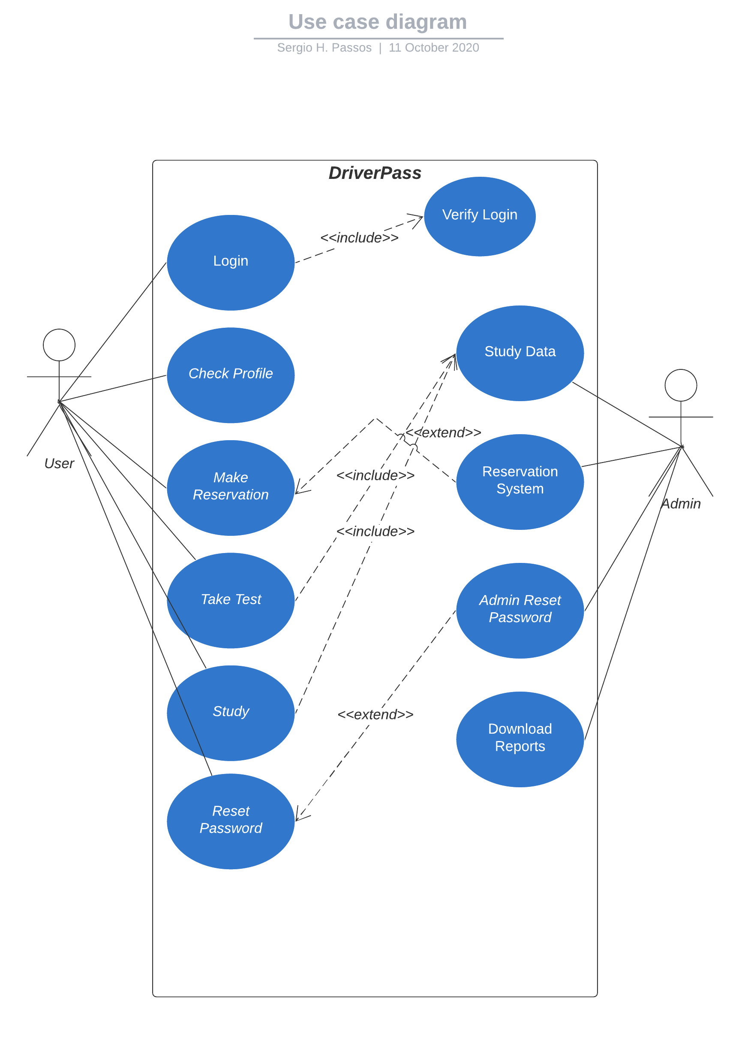

### UML Activity Diagrams

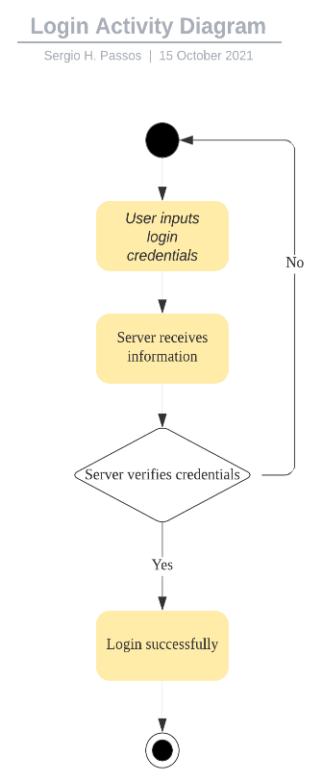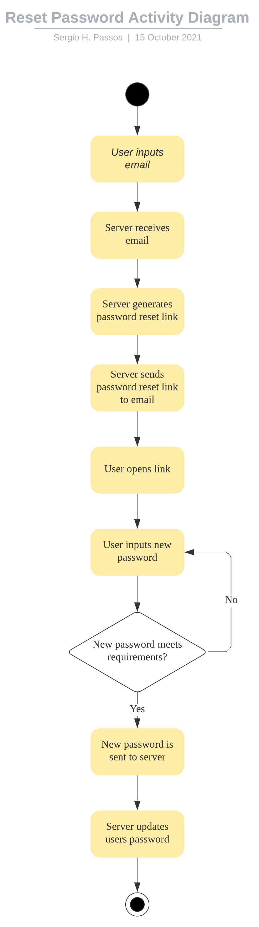

### UML Sequence Diagram

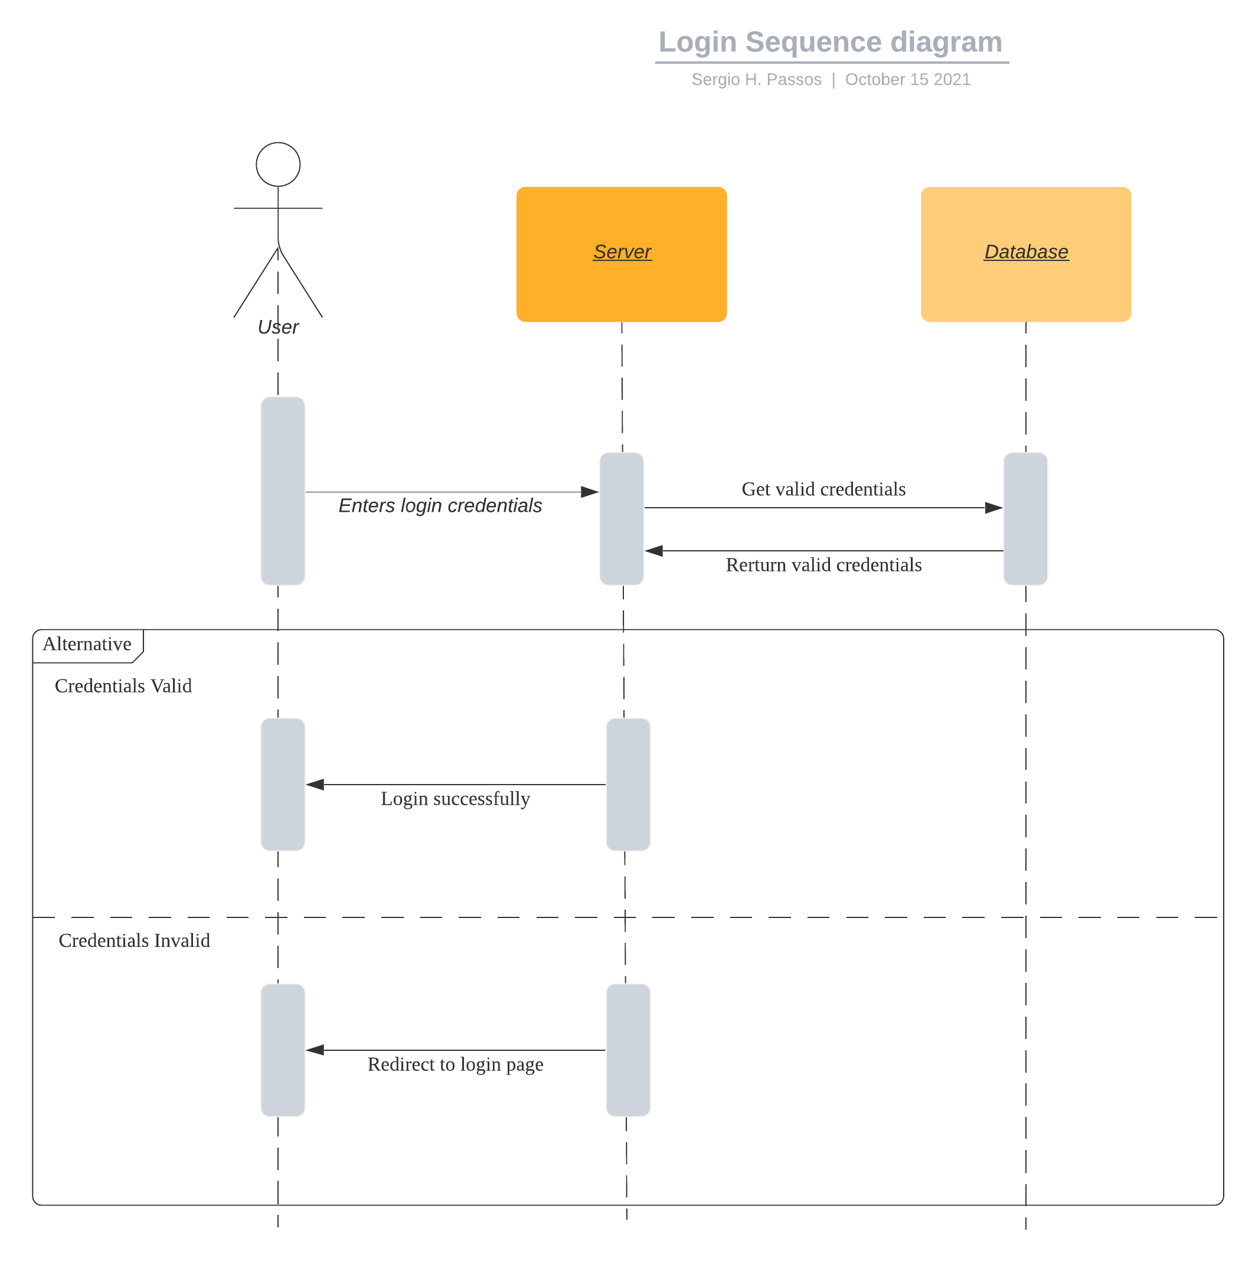

### UML Class Diagram

